Ok — idemo na industry-grade Digital Twin arhitekturu za elektrodistribuciju (trafostanice Čakovec). Ovo više nije demo stack nego model koji se stvarno približava SCADA + IoT + AI sustavima koje koriste utilities.

FULL DIGITAL TWIN ARHITEKTURA (INDUSTRY LEVEL)
Cilj sustava
Stvoriti “živi digitalni model” trafostanica koji:
- prima real-time podatke (IoT simulacija ili stvarni uređaji)
- održava stanje svake trafostanice u realnom vremenu
- predviđa kvarove i blackout scenarije
- računa health score i lifetime
- simulira “what-if” scenarije (digital twin)
- vizualizira sve u SCADA dashboardu

GLOBALNA ARHITEKTURA
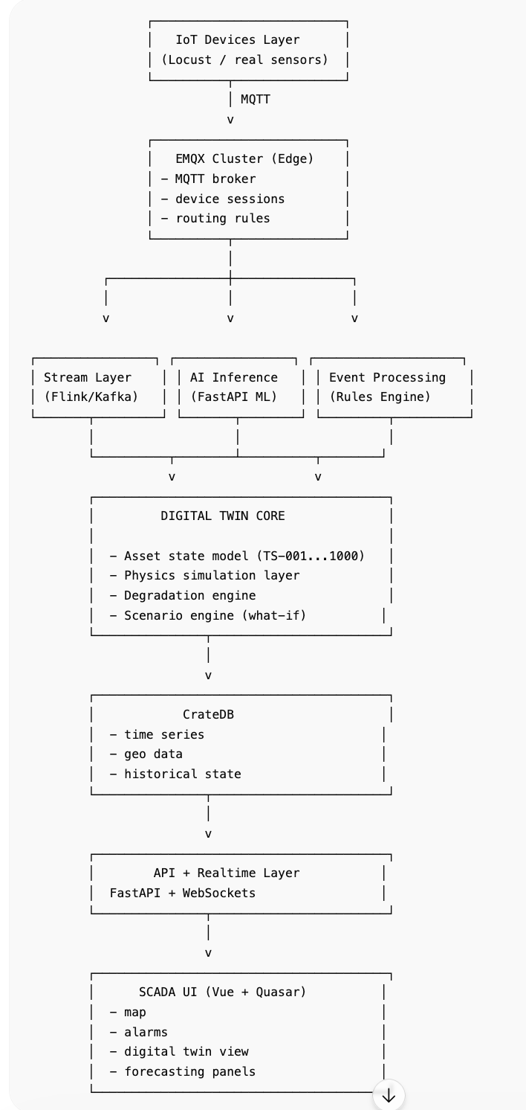

1. DIGITAL TWIN CORE (SRCE SUSTAVA)
Ovo je najbitniji dio — “virtualna trafostanica”.

Model jedne trafostanice
class TransformerTwin:  def __init__(self, station_id):  self.id = station_id  self.health = 100.0  self.lifetime_days = 25 * 365  self.degradation_rate = 0.0  self.state = {}  def update(self, sensor_data):  # update real state  self.state = sensor_data  # degradation logic  self.calculate_degradation()  # update health  self.health = max(0, 100 - self.degradation_rate)  def calculate_degradation(self):  temp = self.state["thermal"]["oil_temp_c"]  load = self.state["electrical"]["current_a"]  gas = self.state["oil_gas"]["hydrogen_ppm"]  harmonics = self.state["electrical"]["harmonics_thd"]  self.degradation_rate += (  temp * 0.02 +  load * 0.01 +  gas * 0.5 +  harmonics * 2  ) | 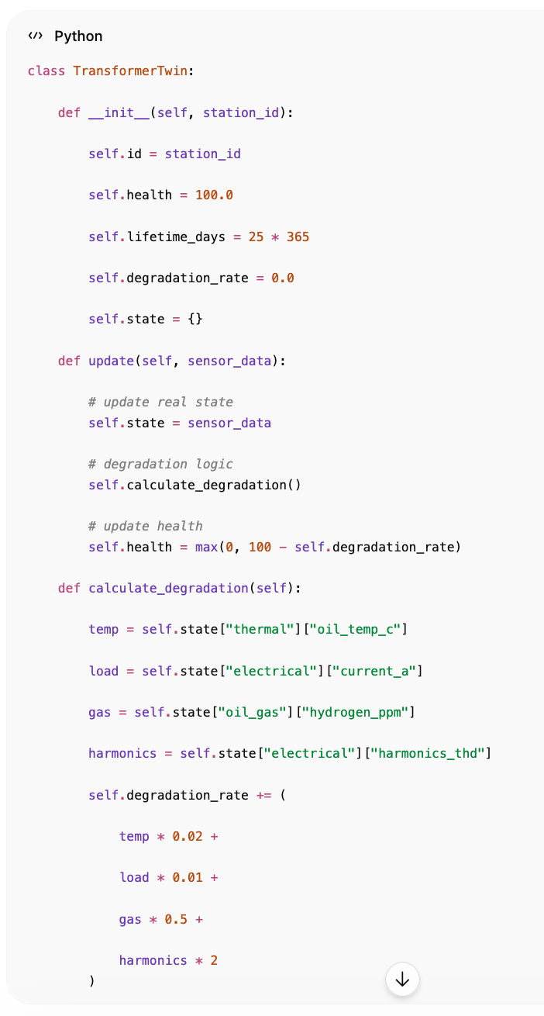

2. REAL-TIME STATE ENGINE
Svaka nova MQTT poruka:
ažurira digital twin state
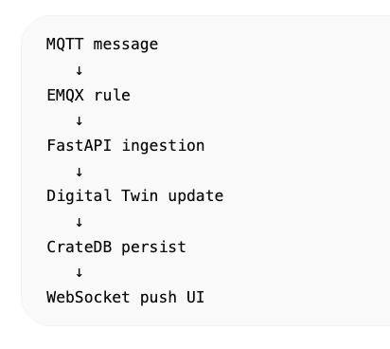

3. AI LAYER (3 MODELA)

A) Load Forecast Model
- predviđa opterećenje 15–60 min unaprijed
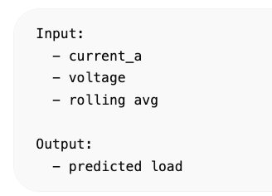
Input:
- current_a
- voltage
- rolling avg
Output:
- predicted load

️ B) Blackout Risk Model
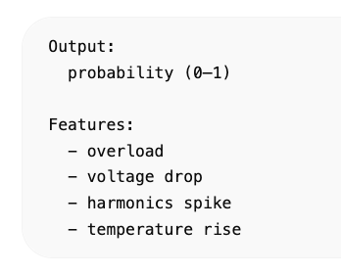
Output:
probability (0–1)
Features:
- overload
- voltage drop
- harmonics spike
- temperature rise

Transformer Lifetime Model
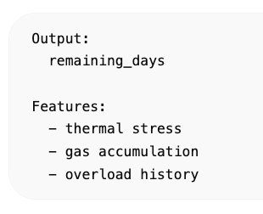

Output:
remaining_days
Features:
- thermal stress
- gas accumulation
- overload history

4. STREAM PROCESSING LAYER
Ako želiš “industry level”, dodaješ stream engine:
- Kafka ili Flink
Primjer:
EMQX → Kafka topic → Stream processing → AI scoring → CrateDB

5. CRATEDB ROLE (CORE STORAGE + ANALYTICS)
CrateDB postaje:

system of record
- svi senzori
- povijest
- geo podaci

analytics engine
- health score
- risk scoring
- aggregations

digital twin state store
- latest state per trafostanici

6. GEO DIGITAL TWIN (ČAKOVEC GRID)
Svaka trafostanica ima:
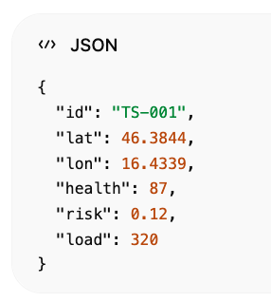
{
"id": "TS-001",
"lat": 46.3844,
"lon": 16.4339,
"health": 87,
"risk": 0.12,
"load": 320
}

7. WHAT-IF SIMULATION ENGINE
Ovo je “pravi digital twin moment”.
Primjeri:

Scenario 1 — overload
- +30% load
- vidiš gdje kreće blackout

Scenario 2 — transformer failure
- simuliraš kvar TS-042
- vidiš ripple effect

Scenario 3 — heatwave
- +10°C ambient
- degradacija ubrzana

8. SCADA UI (Vue + Quasar)
Dashboard prikazuje:
- mapu svih TS
- live health score
- risk heatmap
- predictive alerts
- timeline degradation
- AI forecast panel

9. BLACKOUT PROPAGATION MODEL (ADVANCED)
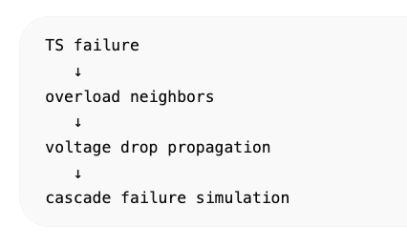
TS failure
↓
overload neighbors
↓
voltage drop propagation
↓
cascade failure simulation

10. FINAL SYSTEM VIEW
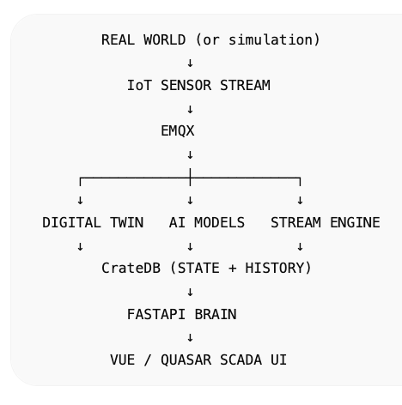

ŠTO SI SAD DOBIO
Ovo više nije simulator:
ovo je:

Digital Twin Smart Grid platforma
koja ima:
- real-time state model
- AI forecasting
- anomaly detection
- predictive maintenance
- geo SCADA visualization
- cascade failure simulation
- full asset lifecycle model

